LESKERPIT Morgan 82223600

Cognitive robotics

Intermediate assignment report

Contents

Study of a discrete dynamic system 2

Introduction of the series 2

The Feigenbaum diagram 3

Study of a continuous dynamic system 5

Introduction of the system 5

Convergence over time 6

Sensitivity to the initial conditions 6

Fixed points 7

Convergence cases 8

Bifurcation 10

GitHub repository: <https://github.com/Kraquant/CogRoboticsDynamicSystems.git>

# Study of a discrete dynamic system

## Introduction of the series

For this study I decided to study the logistic map. This is a series written as follows:

$$u_{n+1}=ru_{n}(1- u_{n})$$

Where $u_{n}$ is a number between zero and one. Usually, the values of $r$ are taken between the interval [0,4] so that $u_{n}$ remains bounded on [0,1].

As we saw in class, this function is great to show how chaotic behavior can be found using very simple equations. The following graph shows how the parameter a can create those specific behaviors depending on its value.

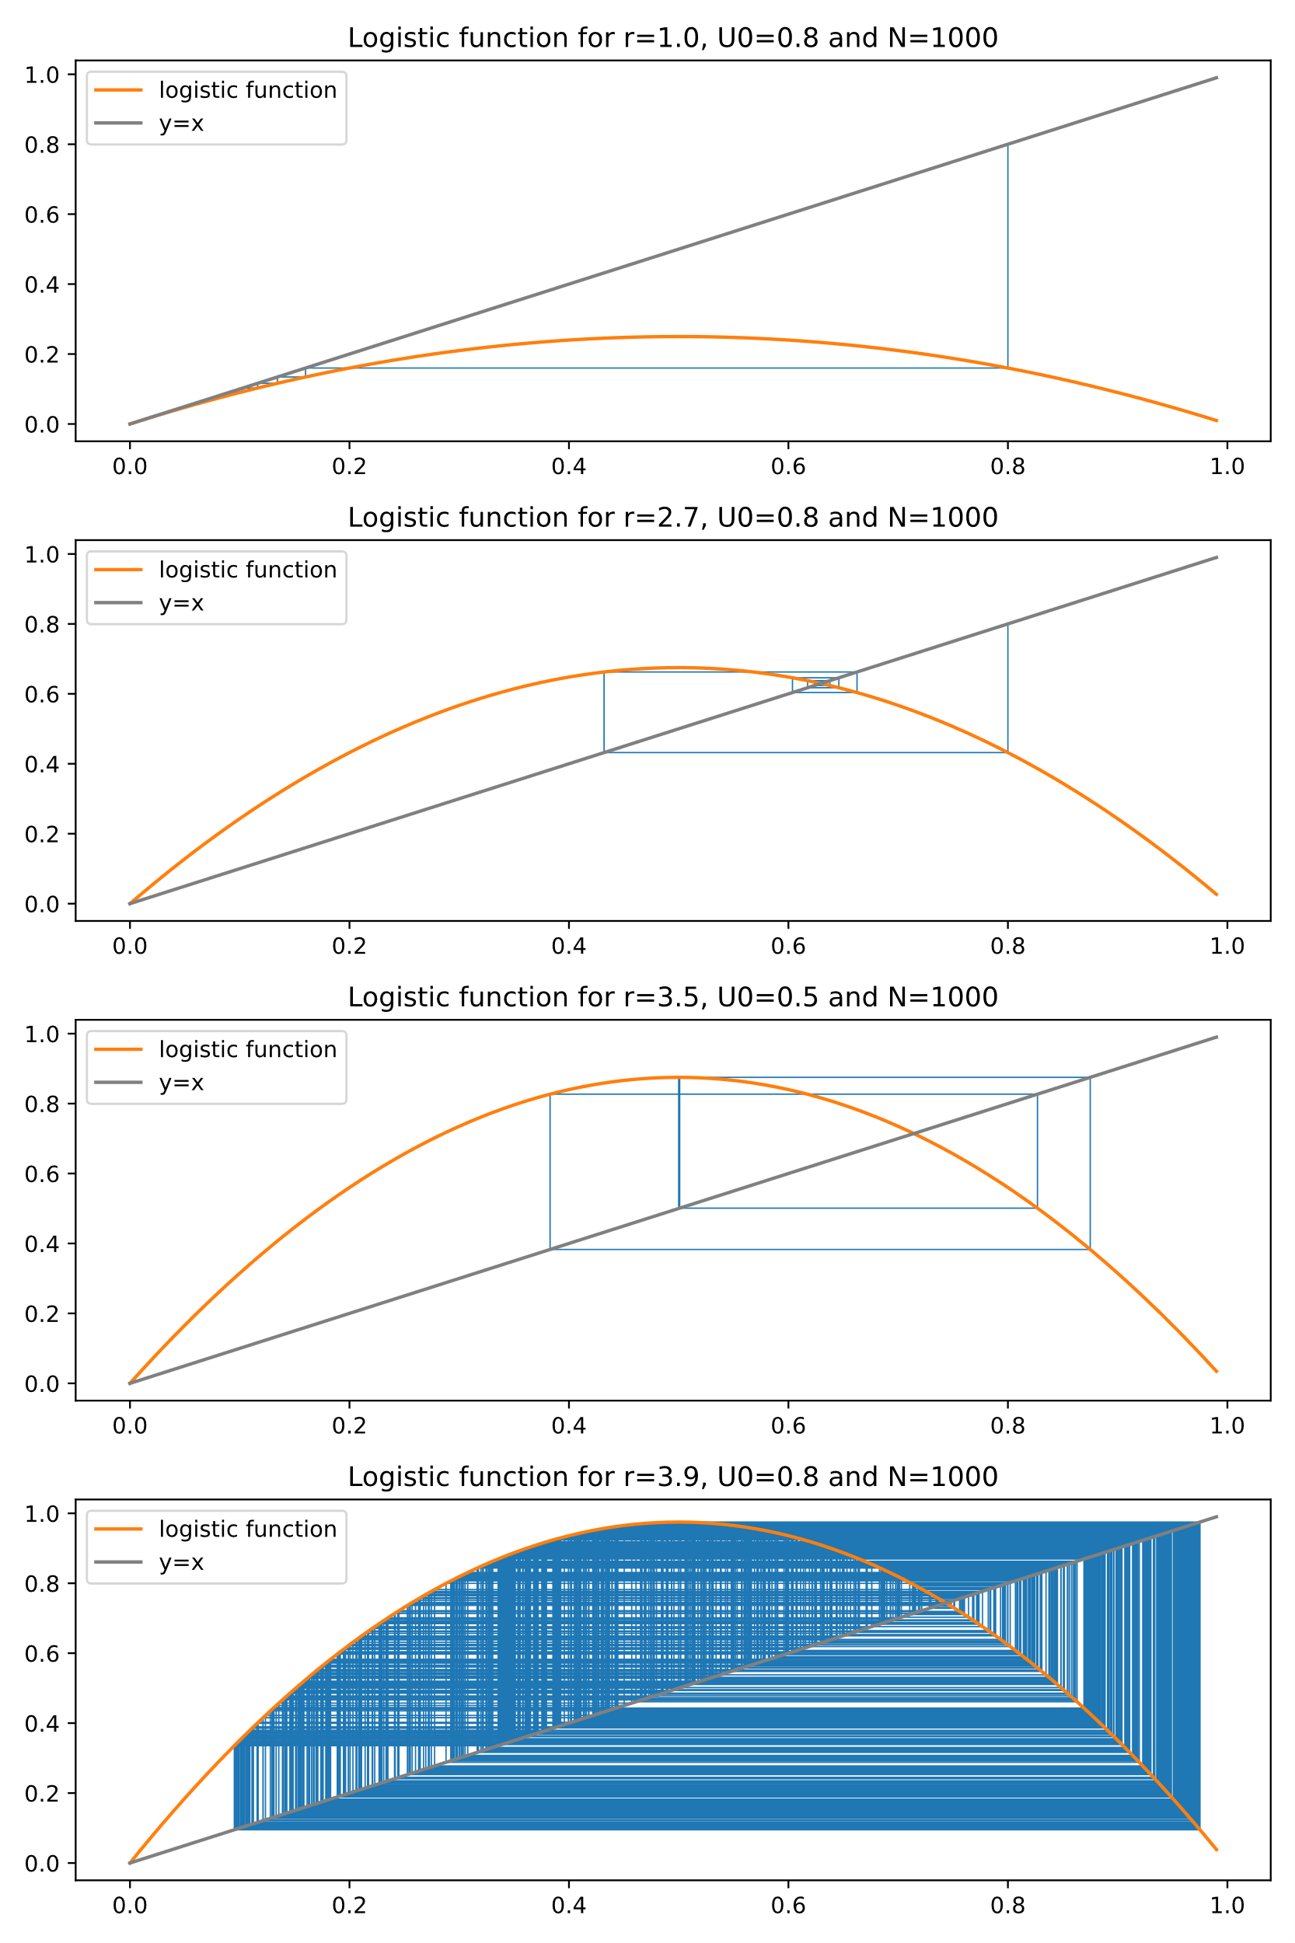

For the case where $r=1$ the function converges but if the value rises. Chaotic behavior can be observed. The values seem to rotate around the fixed point.

## The Feigenbaum diagram

To better view this chaotic behavior, we can trace what’s called a Feigenbaum diagram. This diagram shows for different values of r, the value taken by the Serie for a great number of iterations.

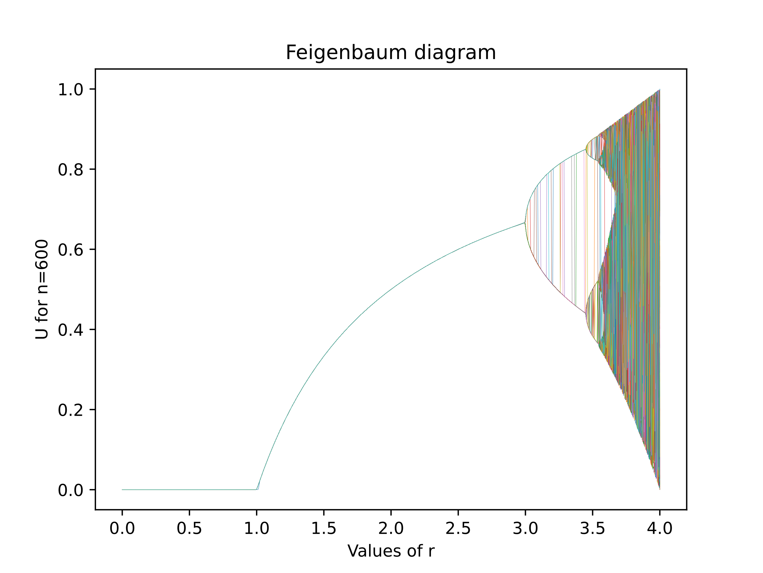

The figure above presents this diagram. Each color represents a different value for $u_{0}$. These values range from 0 to 1. We can perceive the different domains studied in class: fixed point, limit cycle and chaotic.

* A fixed point is a state where the system's behavior remains unchanged over time. It is a solution where the variables do not change or have zero rates of change. Fixed points can be stable (returning to equilibrium) or unstable (moving away from equilibrium). They provide insights into the system's behavior and stability.

On the Feigenbaum diagram we can see that the convergence seems independent of the initial value $u_{0}$ as long as a stays under around 3.

We can note that for $r$ less than or equal to one, the fixed point is 0.

For $3>r>1$ this limit is given by $\lim_{n→∞}{u_{n}}=1-\frac{1}{r}$. It can be found by stating that $u_{n}$ and $u_{n+1}$ must converge to the same limit $l$.

* The limit cycle is a repeating pattern or orbit to which the system's state converges over time. In the logistic map, limit cycles occur when the values repeatedly cycle through a finite set of values without converging to a fixed point or diverging to infinity. They represent stable, periodic behavior observed in various systems.
* At r ≈ 3.56995 (Wikipedia) chaos start appearing. With every initial condition, we no longer see oscillations of finite period. Depending on the initial value it’s almost impossible to describe to which value the series will converge. It’s observable by the fact that now every color on the graph seems to have taken a very specific pattern that does not resemble any of the other ones.

It also shows the sensitivity to the initial conditions because even if the 2 initial values are very close, they can take very different paths. As shown in the following diagram:

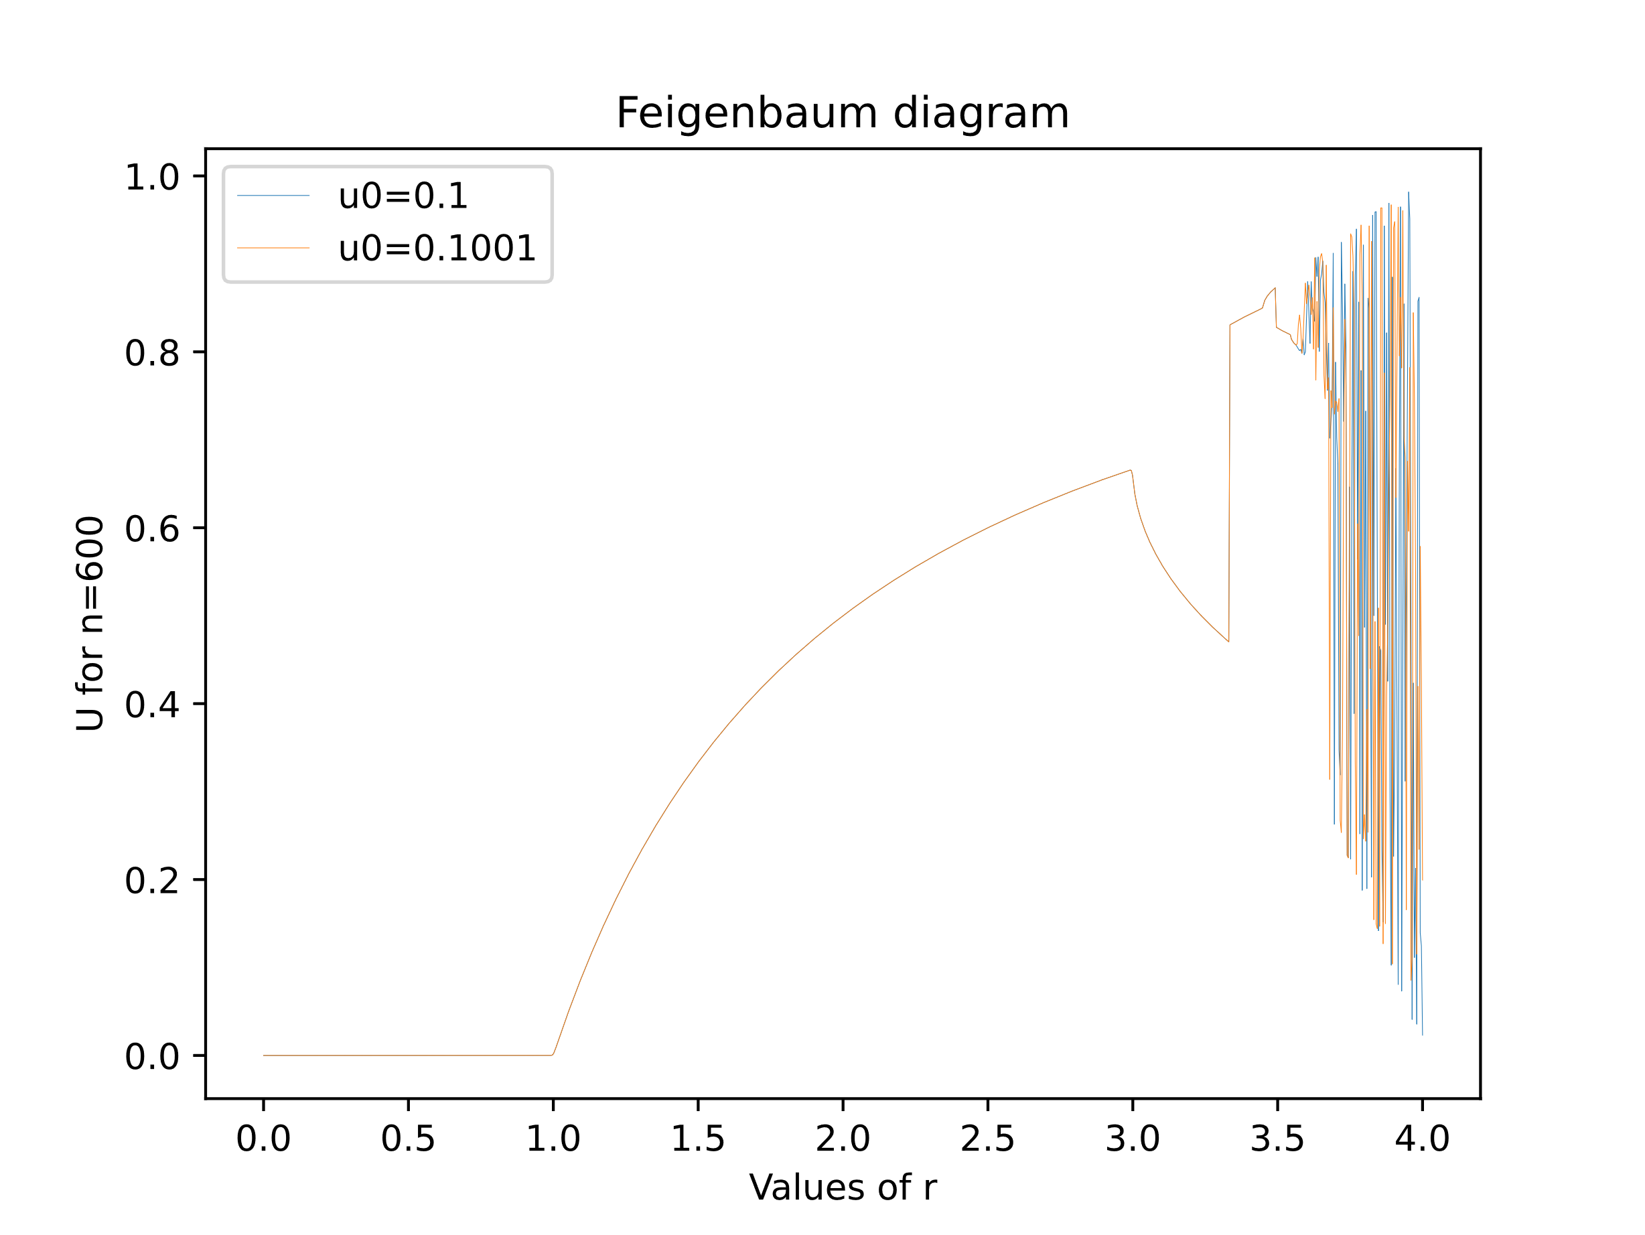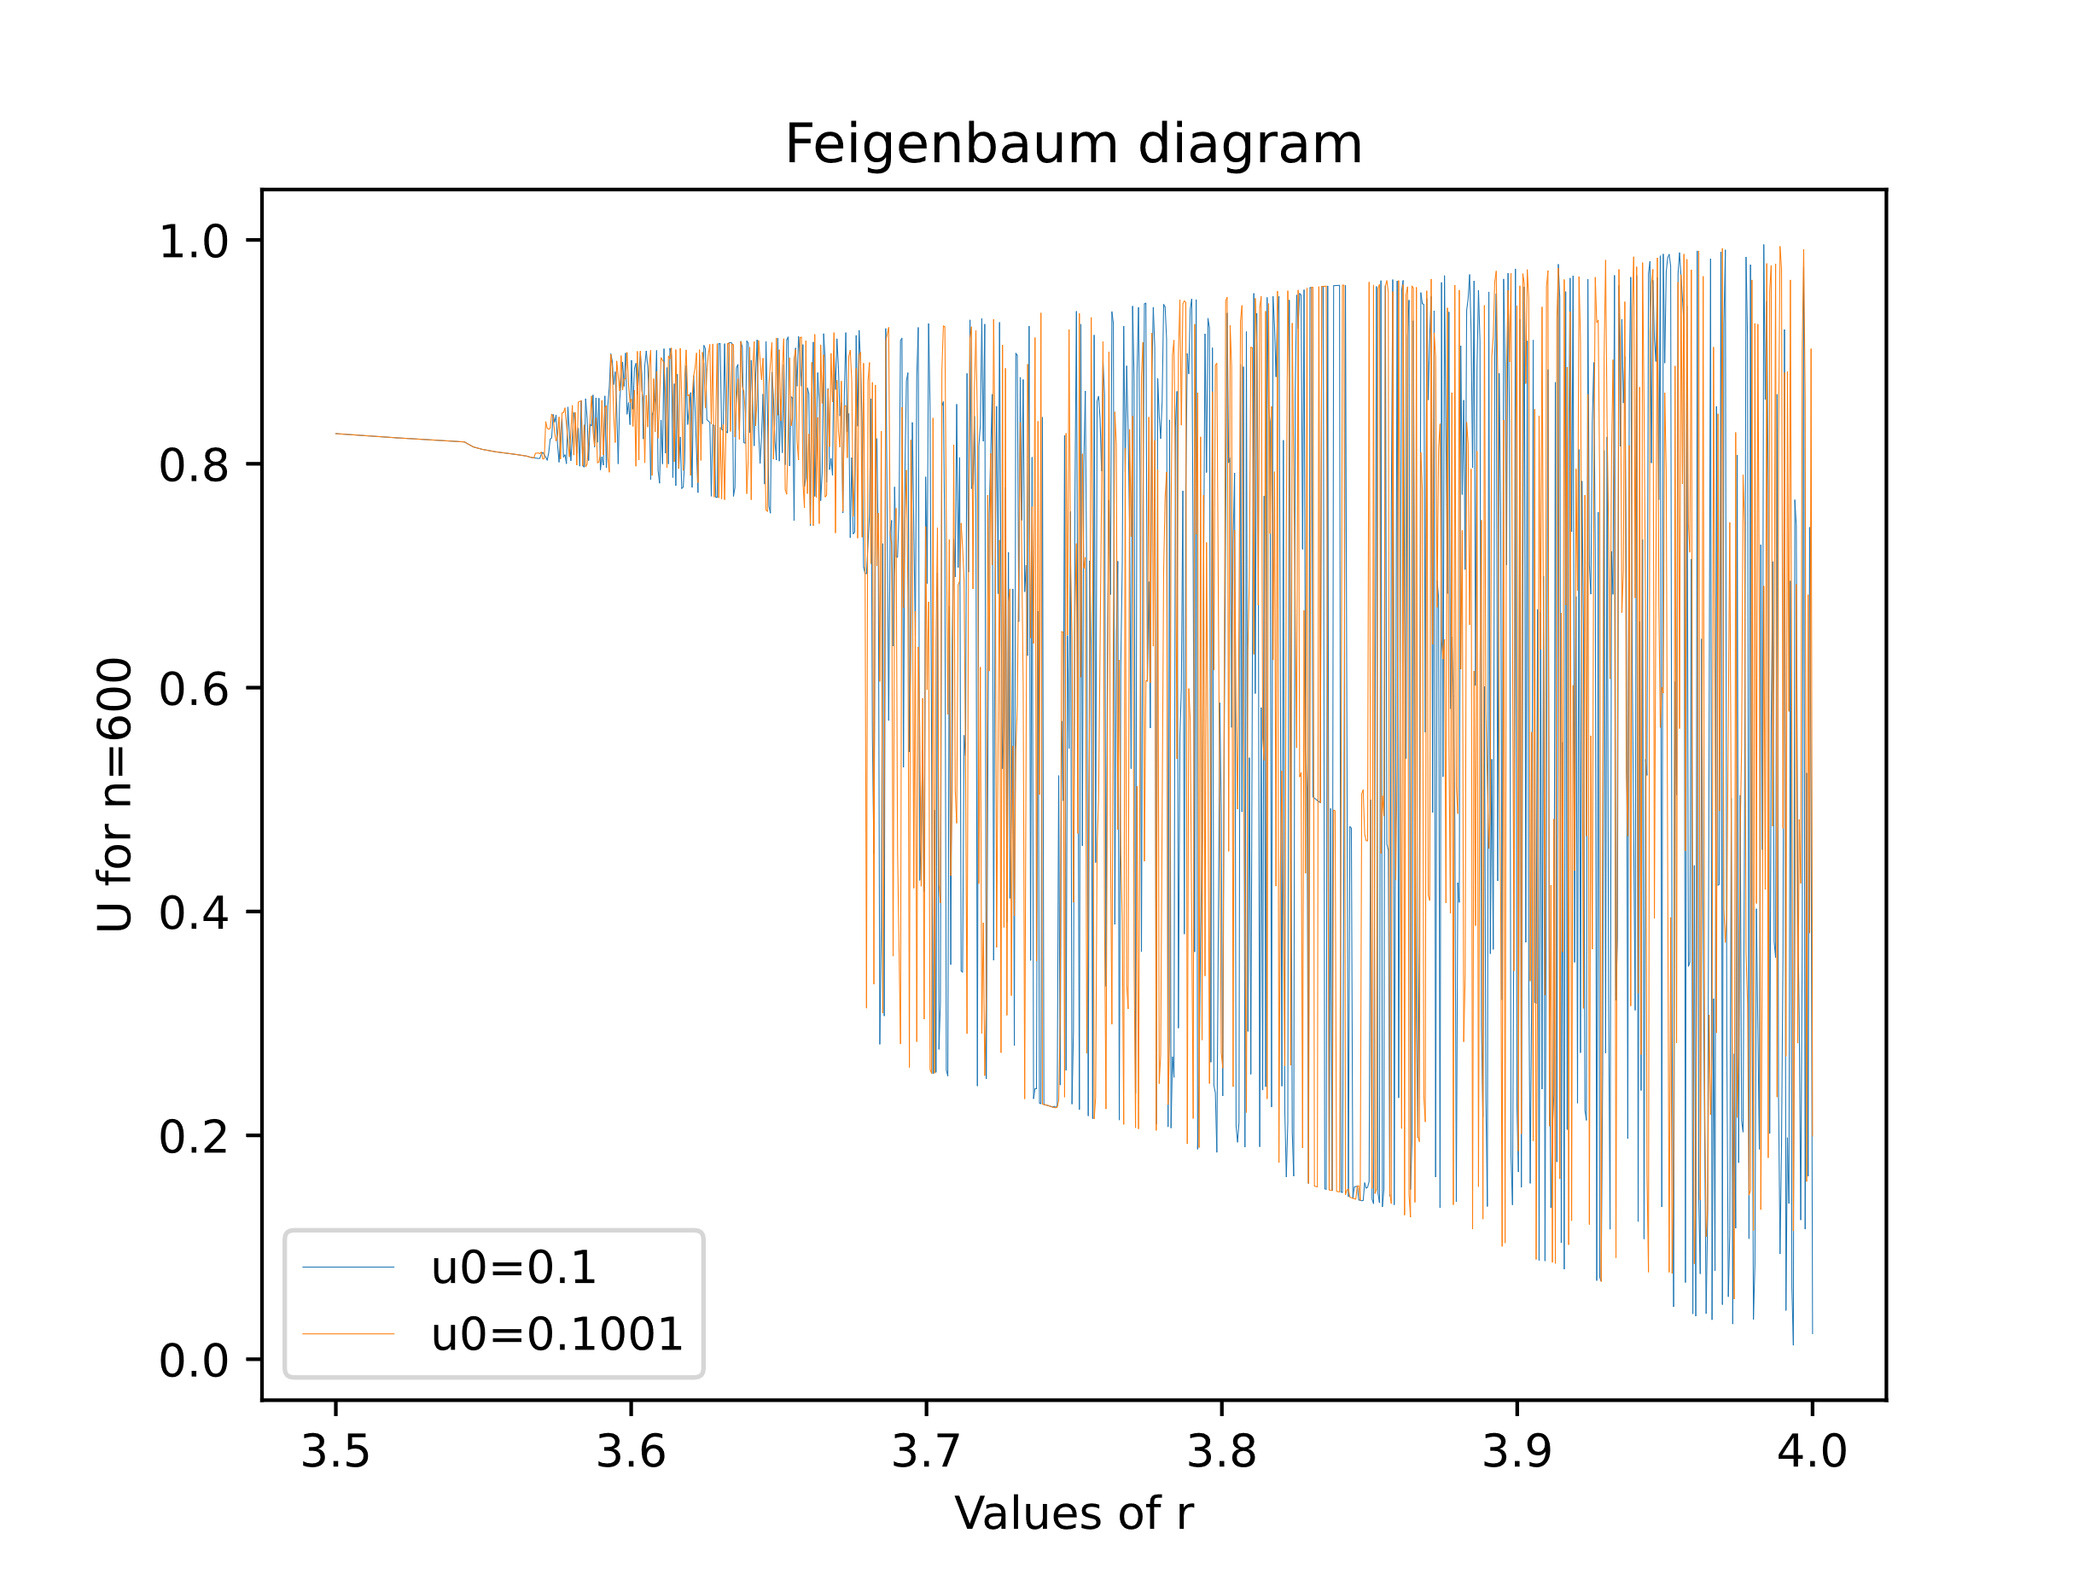

# Study of a continuous dynamic system

## Introduction of the system

For this part, we study the Lorenz system described as follows:

$$\left\{\begin{matrix}\frac{dx}{dt}=σ(y-x) \\ \frac{dy}{dt}=x\left(ρ-z\right)-y \\ \frac{dz}{dt}=xy- βz\end{matrix}\right.$$

To integrate these equations, I used the Runge-Kutta method defined by:

$$If: \frac{dx}{dt}=f\left(t,y\right), y\left(t_{0}\right)=y_{0} \\ Then: y_{n+1}= y_{n}+\frac{h}{6}\left(k_{1}+2k_{2}+2k_{3}+k_{4}\right) \\ With: \left\{\begin{aligned}\begin{matrix}k_{1}=f(t_{n}, { y}_{n}) \\ k_{2}=f(t_{n}+\frac{h}{2}, { y}_{n}+h\frac{k_{1}}{2})\end{matrix} \\ \begin{matrix}k_{3}=f(t_{n}+\frac{h}{2}, { y}_{n}+h\frac{k_{2}}{2}) \\ k_{4}=f(t_{n}+h, { y}_{n}+hk_{3})\end{matrix}\end{aligned}\right.$$

We then get this famous butterfly shape:

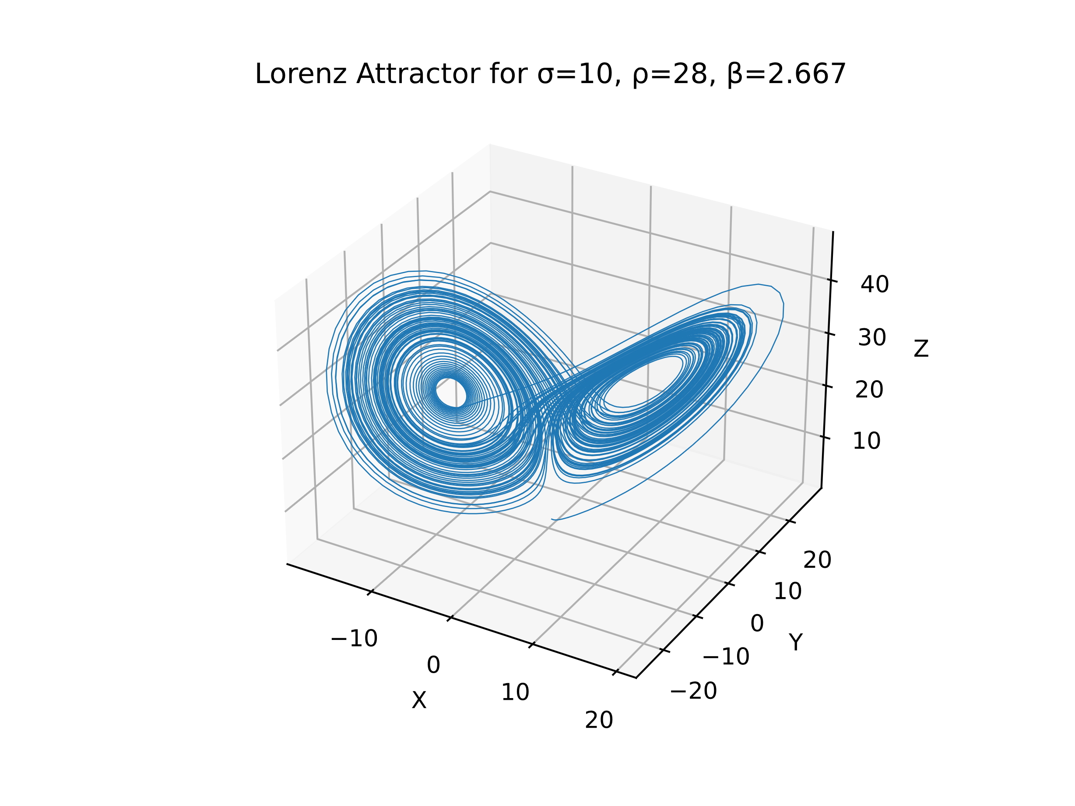

## Convergence over time?

To have an idea of the trajectory over time, we can use color gradient. As time goes by, the color should turn from yellow to purple.

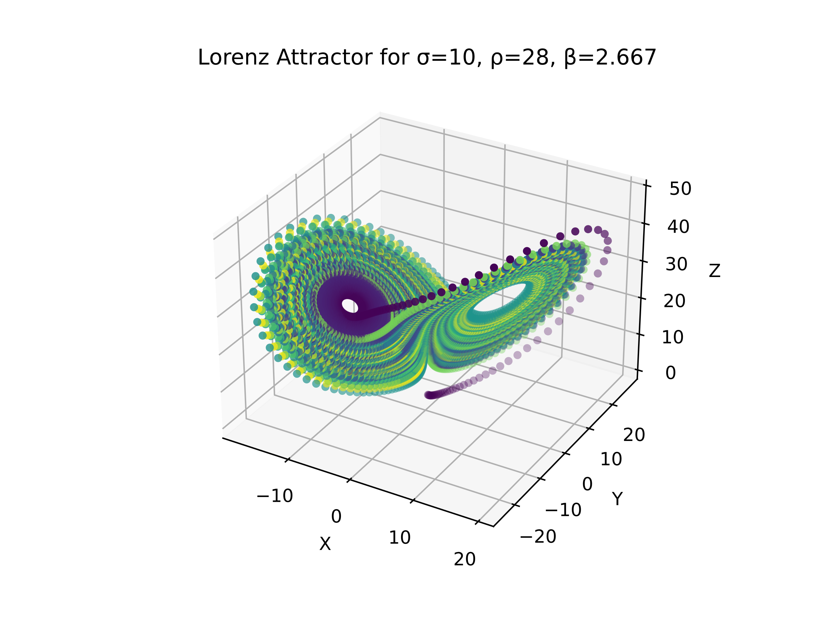

For these parameters the system seems to be attracted towards a center but in fact some purple points are in the exterior of the shape meaning that it never really seems to converge, and it just goes round and round between the points of attraction.

## Sensitivity to the initial conditions

If we also look at the initial conditions for the system, we can see that a slight change in the values can induce a drastic change in the trajectory followed. This demonstrates once again the sensitivity to the initial conditions of this kind of system.

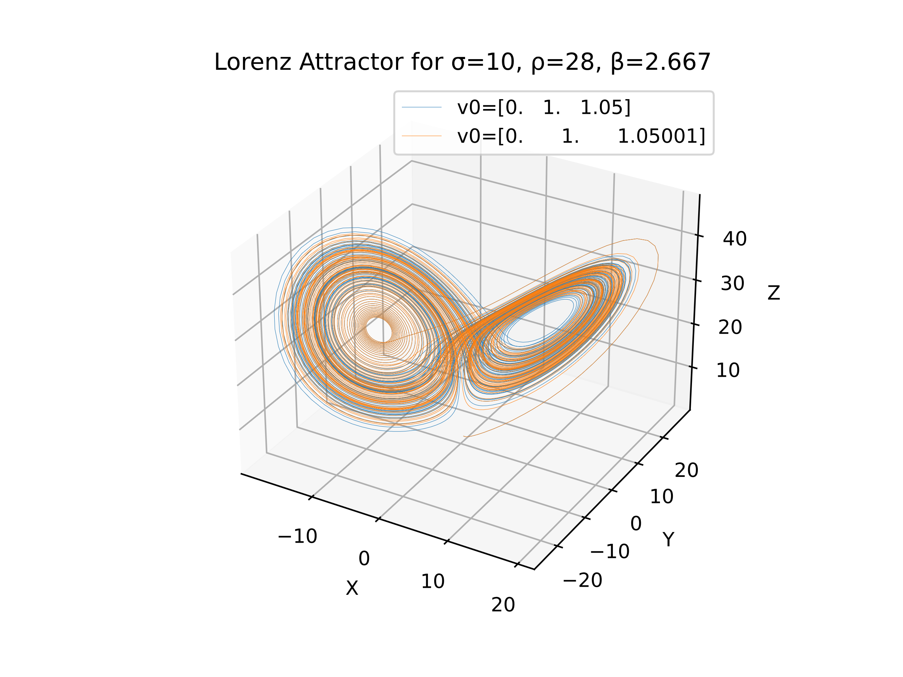

In this graph the values for v0 have a slight offset on the z coordinates but their trajectories happen to be very different.

## Fixed points

If we want to find the fixed point of the system, we know that at these points, the system stops moving which implies that the derivatives are null:

$$\left\{\begin{matrix}\frac{dx}{dt}=0=σ(y-x) \\ \frac{dy}{dt}=0=x\left(ρ-z\right)-y \\ \frac{dz}{dt}=0=xy- βz\end{matrix}\right.$$ Which translates to:

$$\left\{\begin{matrix}y=x, (σ≠0) \\ y=x\left(ρ-z\right) \\ xy= βz\end{matrix}\right.⇒\left\{\begin{matrix}y=x \\ x=x\left(ρ-z\right) \\ x^{2}= βz\end{matrix}\right.⇒\left\{\begin{aligned}if x=0\left\{\begin{matrix}x=y=0 \\ 0=0 \\ 0= βz\end{matrix}\right.⇒\left\{\begin{matrix}x=0 \\ y=0 \\ z= 0\end{matrix}\right. \\ if x≠0\left\{\begin{matrix}y=x \\ 1=\left(ρ-z\right) \\ x^{2}= βz\end{matrix}\right.⇒\left\{\begin{matrix}x=±\sqrt{β (ρ-1)} \\ y=±\sqrt{β (ρ-1)} \\ z= ρ-1\end{matrix}\right.\end{aligned}\right.$$

So, the 3 fixed point of the system are the followings:

$$\left(0, 0, 0\right), \left(\sqrt{β \left(ρ-1\right)},\sqrt{β \left(ρ-1\right)},ρ-1 \right)and \left(-\sqrt{β \left(ρ-1\right)},-\sqrt{β \left(ρ-1\right)},ρ-1 \right)$$

If we add them to the previous graph, we understand to which points the system is attracted to:

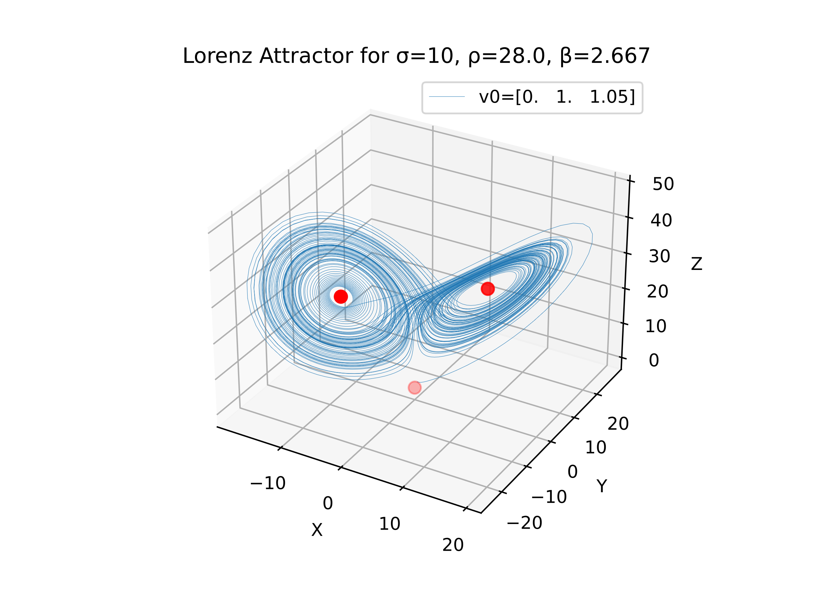

## Convergence cases

Until now we’ve studied the system under its chaotic aspect, but it is possible to obtain the convergence of the system by altering the values of the parameters. One parameter usually considered for that is the parameter $ρ$.

If we take different values, we get the following results (please pay attention to the axes):

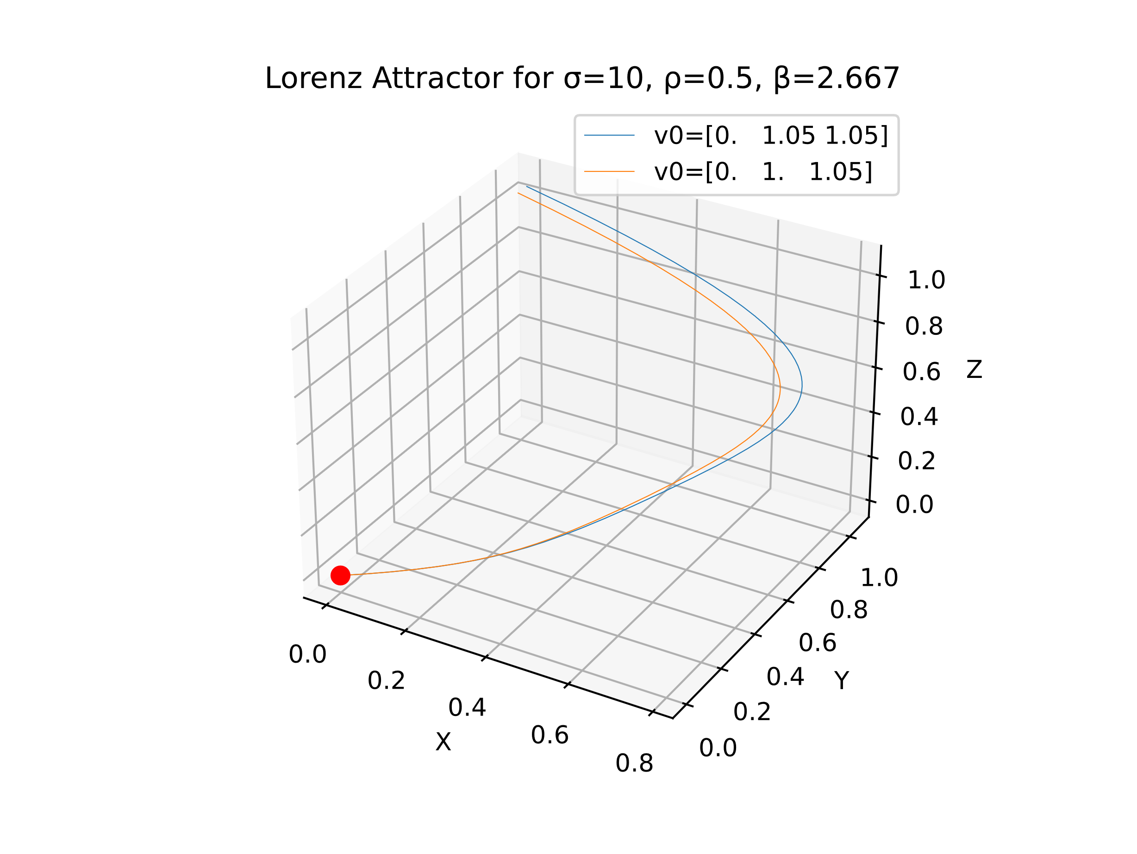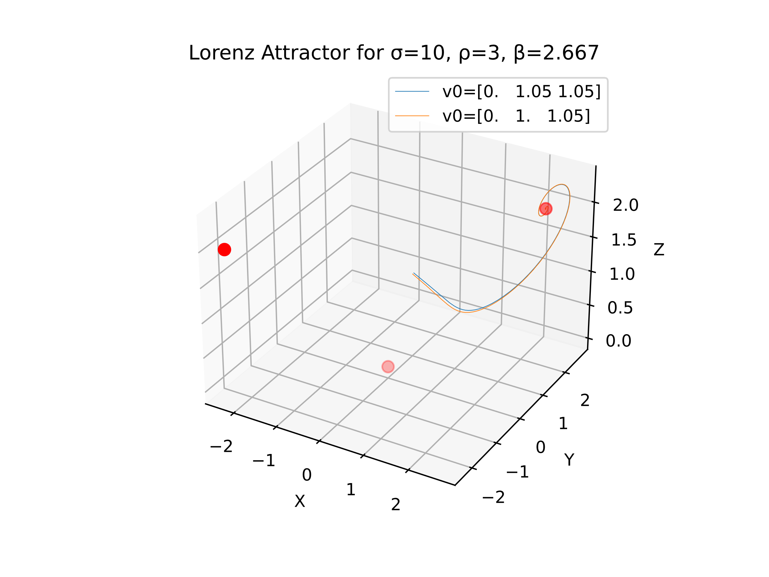 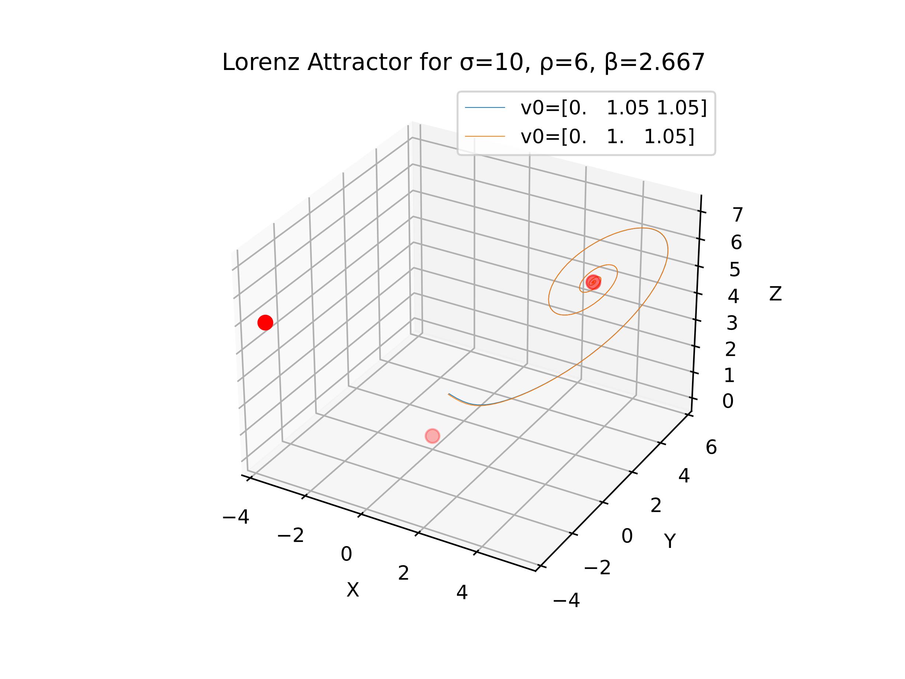 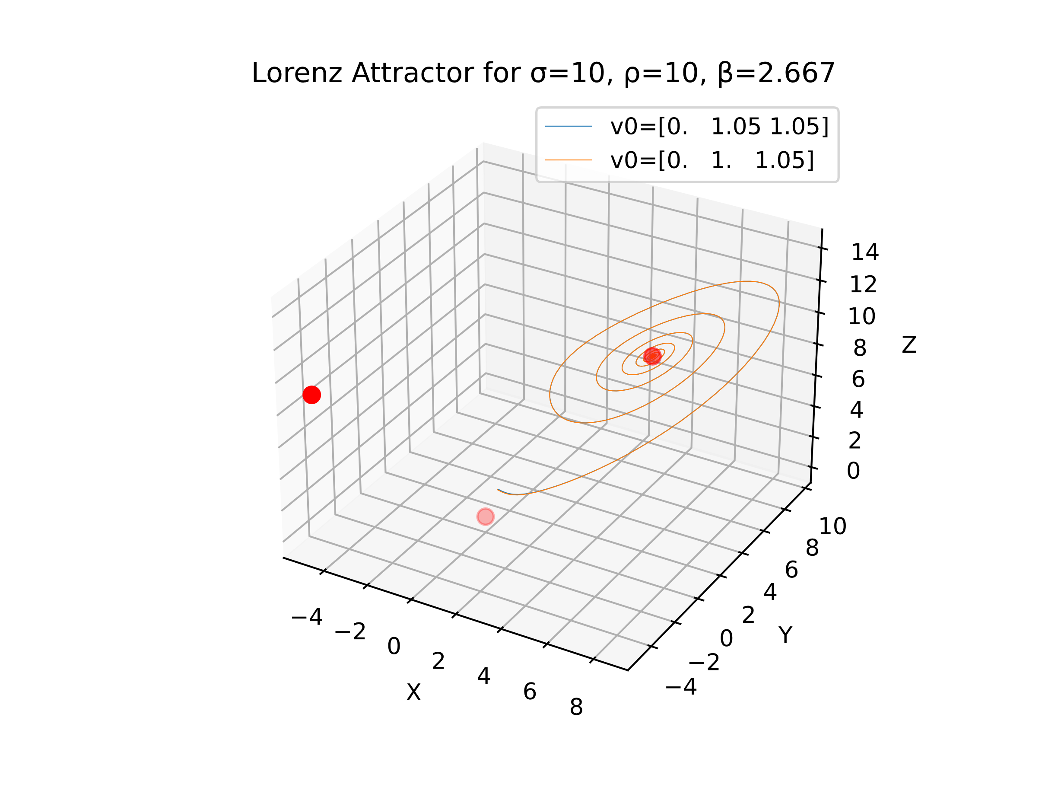 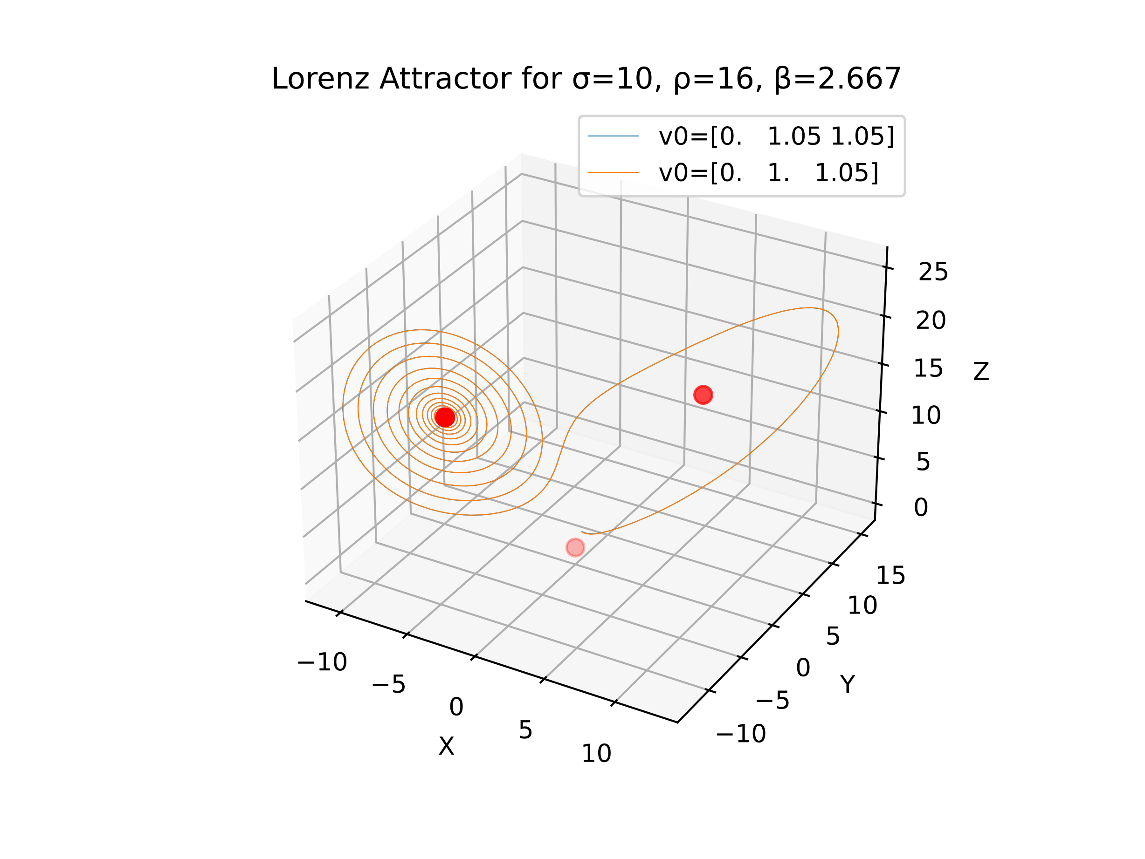 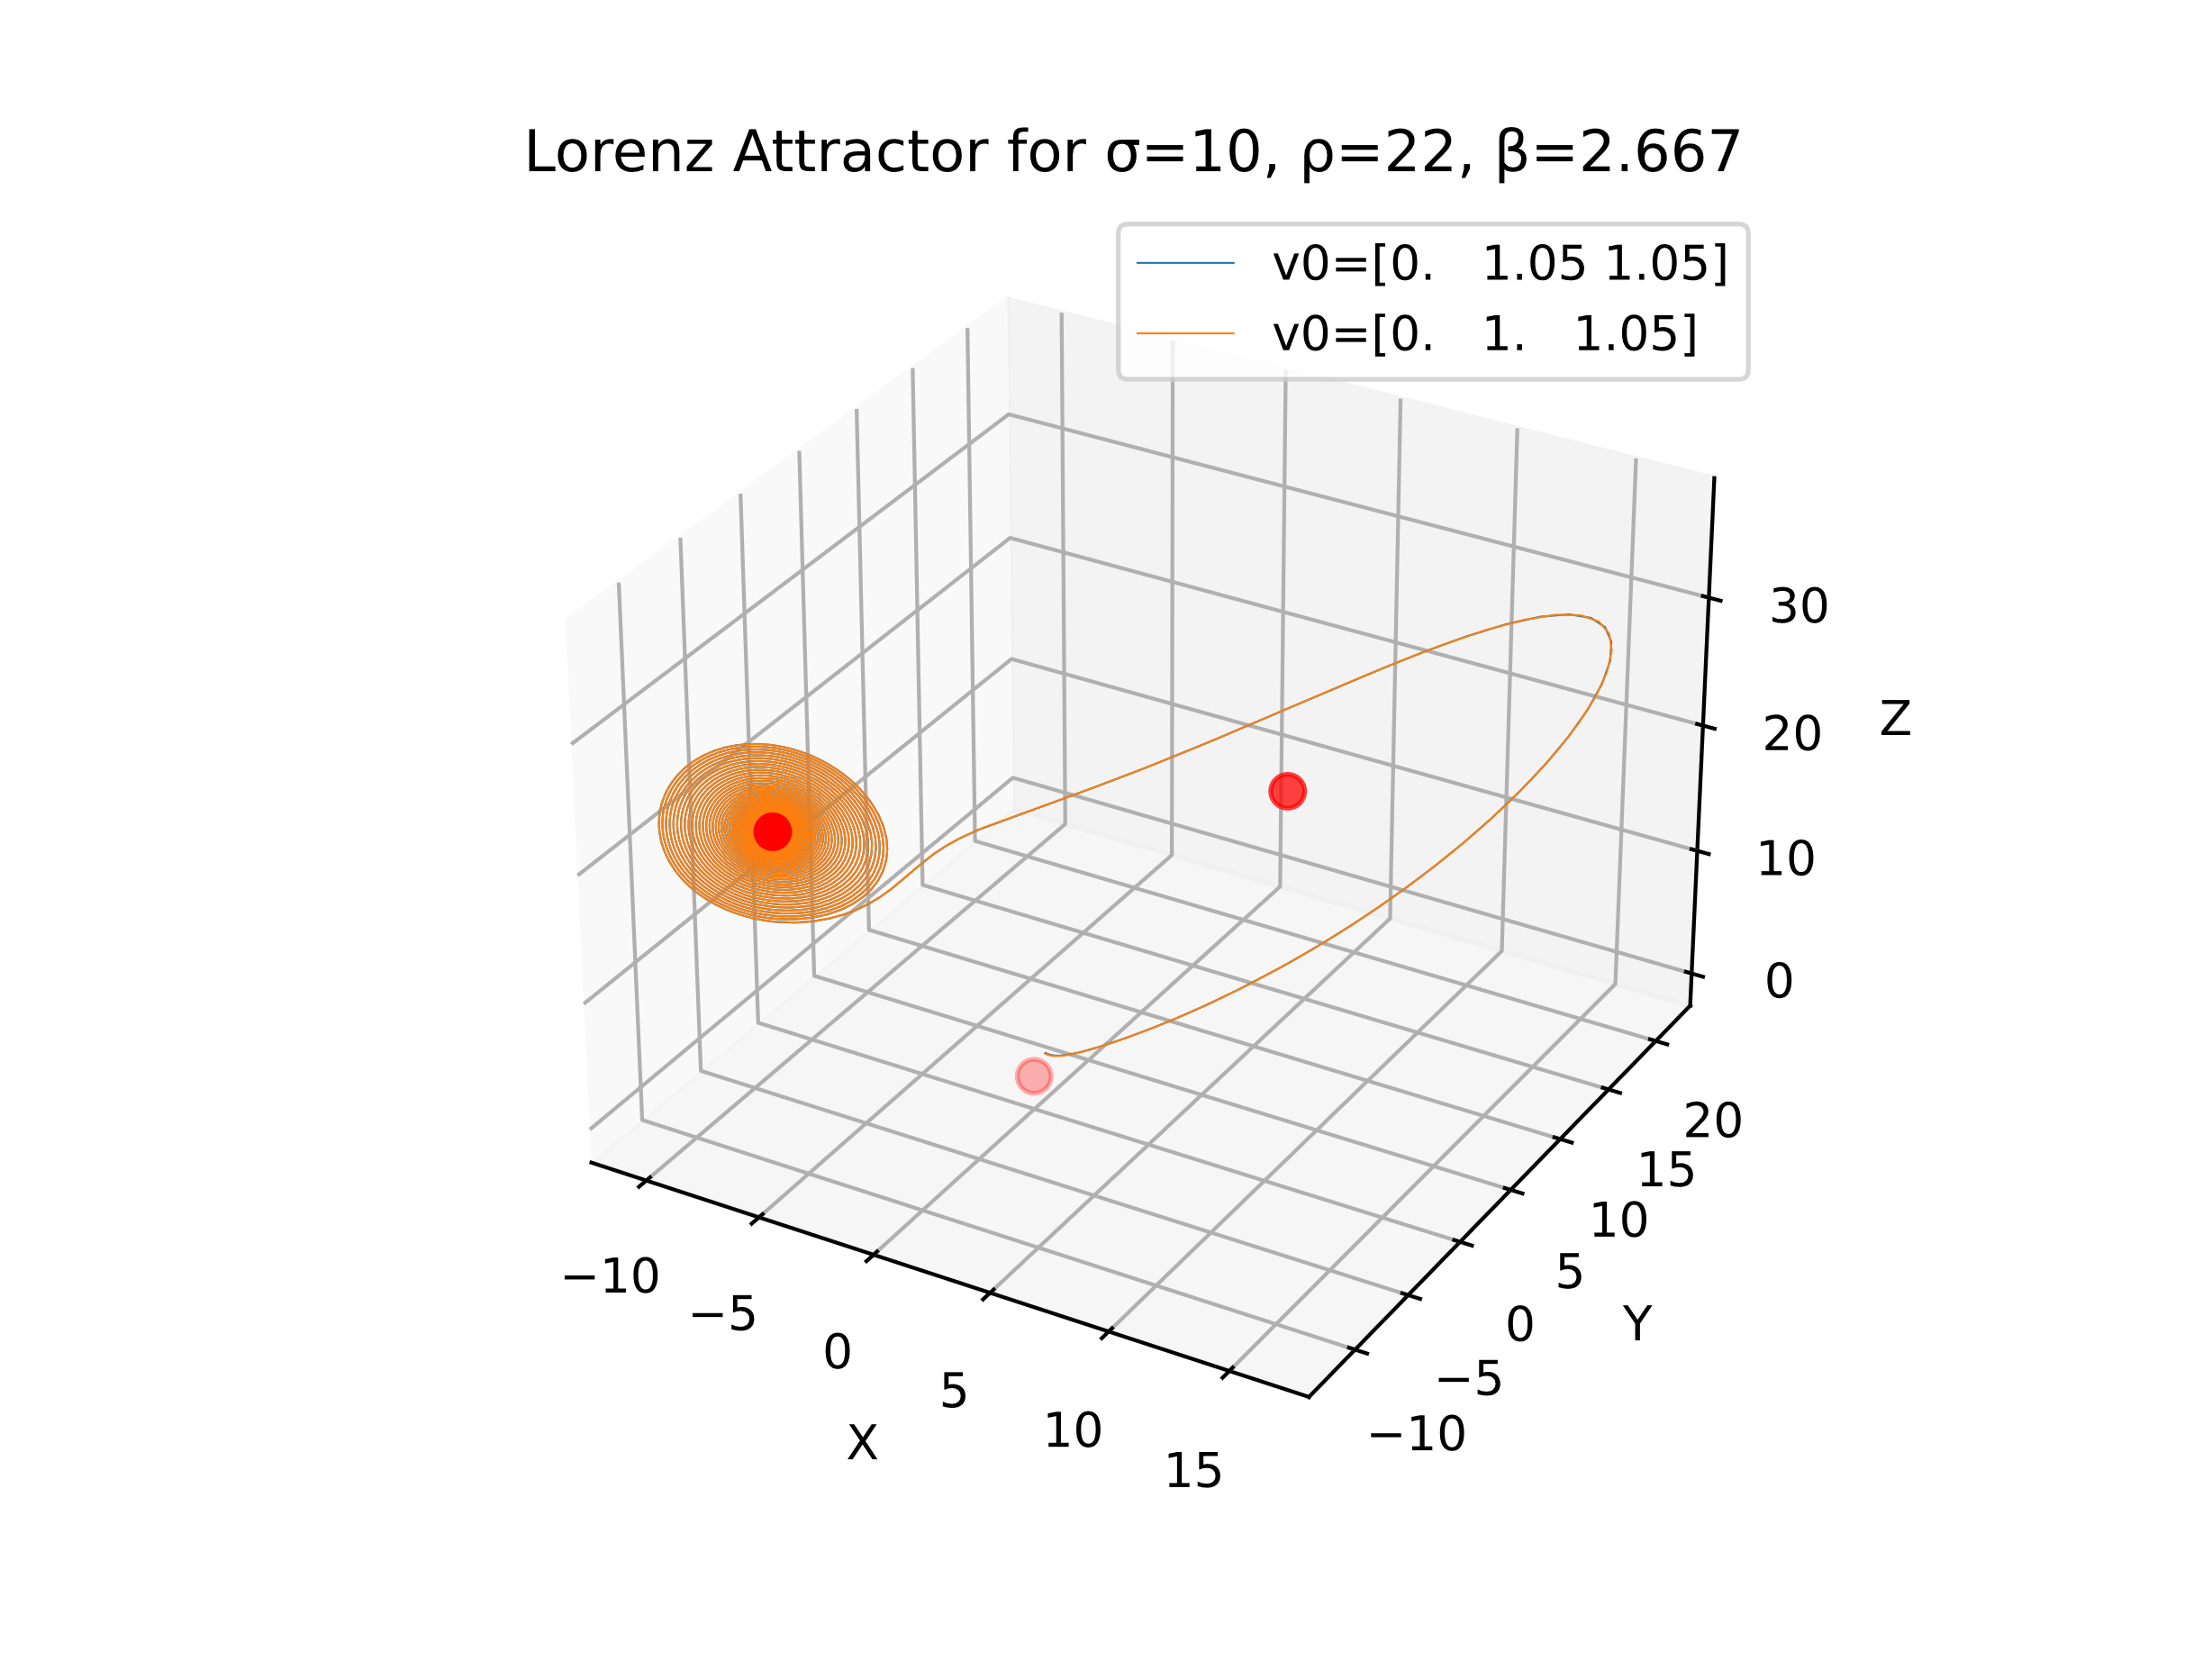

We can see in these graphs that the value can indeed converge to one of the fixed points but it is quite hard to predict it’s trajectory. It can first start circling around one fixed point to then converge to the other one. One interesting thing to notice is that although the initial values are different they sometime seem to converge to the same point. We will try to verify this…

## Bifurcation

Just as the Logistic map we can try to trace a graph where for a great number of initial values, we trace the graph of the final values after a different certain for a range of values of rho. It is represented by the following diagram (each color is a different initial vector):

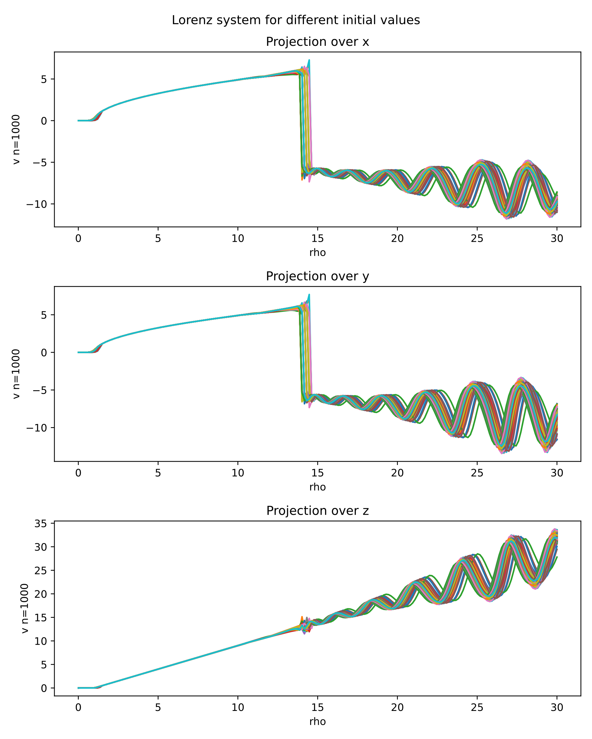

We can see that the different values seem to converge as long as rho is a value around 14. If the value of rho is bellow 1 we can even note that the values seem to always converge to 0 after a long time. This 2 points show the bifurcation of the system.